Assignment No : 1

Working with IAM.

1. Create a user.
2. List of users.

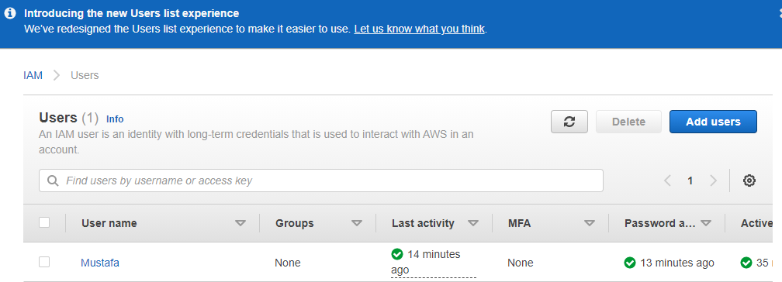

1. User Details.

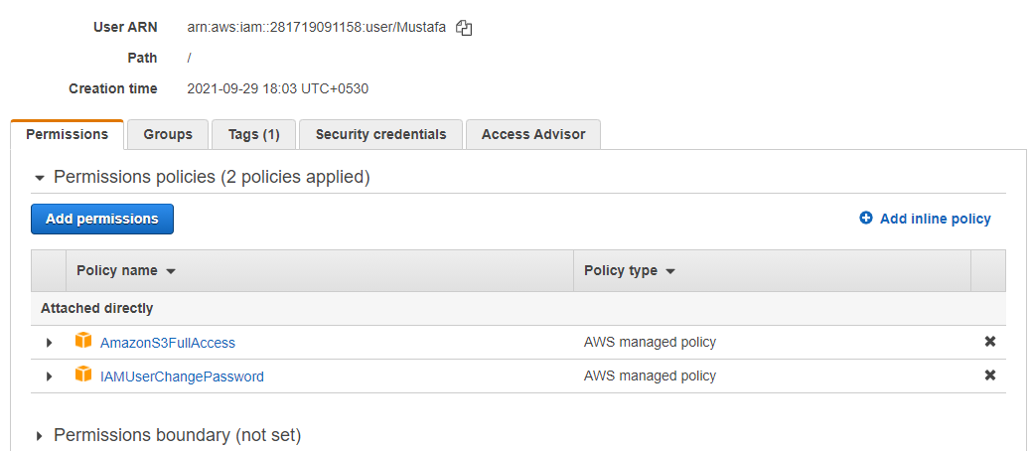

1. Aws Managed policy to the user.
2. Policy of user.

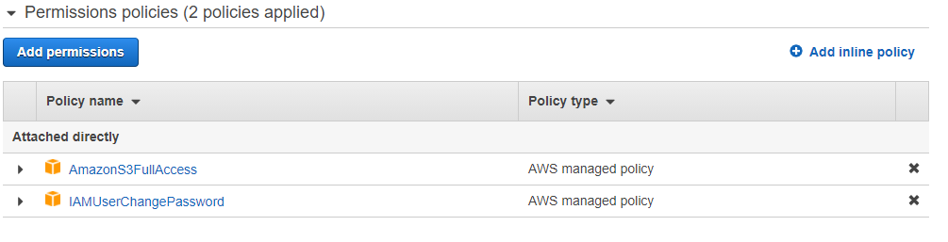

1. Login as IAM User.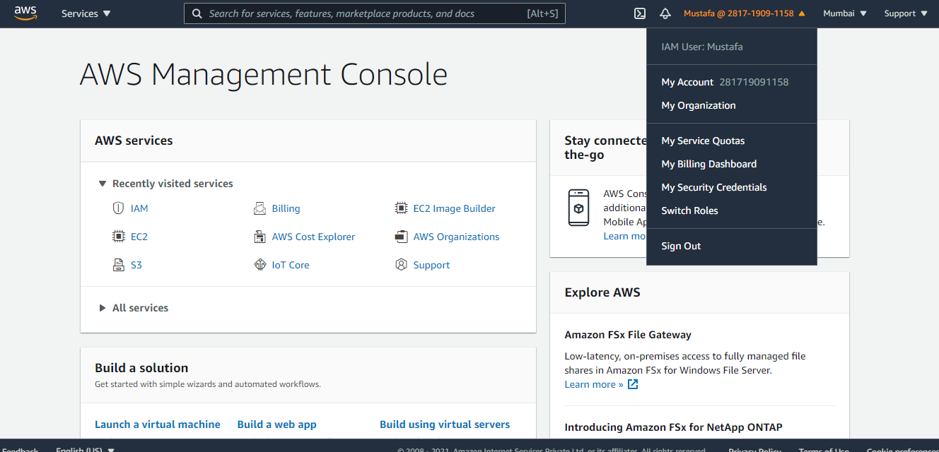
2. Show the IAM permissions in action.
3. S3 Bucket Access as per the policy of user.

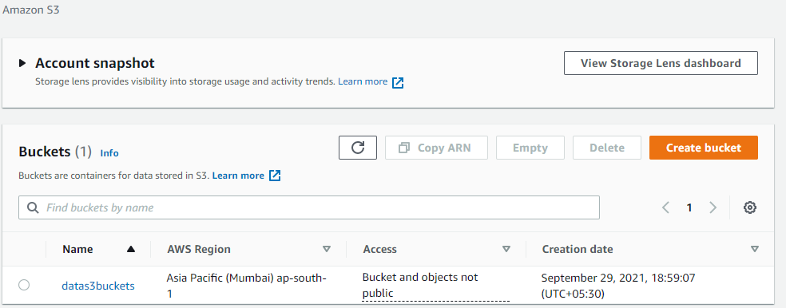

1. EC2 Access deined as per the policy of user.

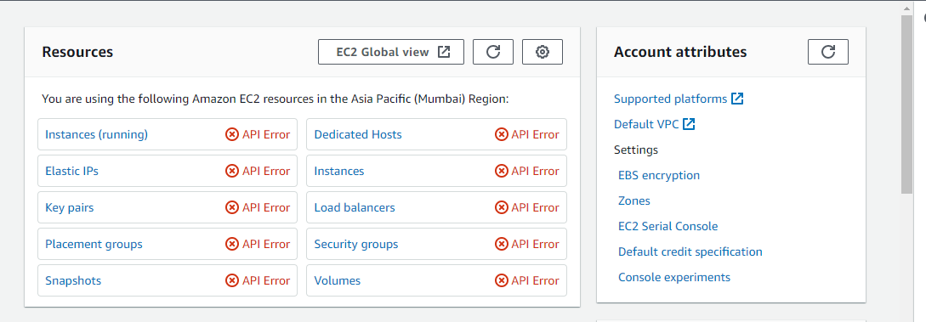

Assignment No : 2

Creating a EC2 instance with termination protection.

1. Create an EC2 instance.
2. Instance Type.

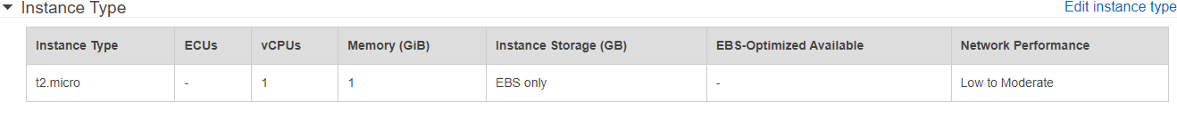

1. Security Group.

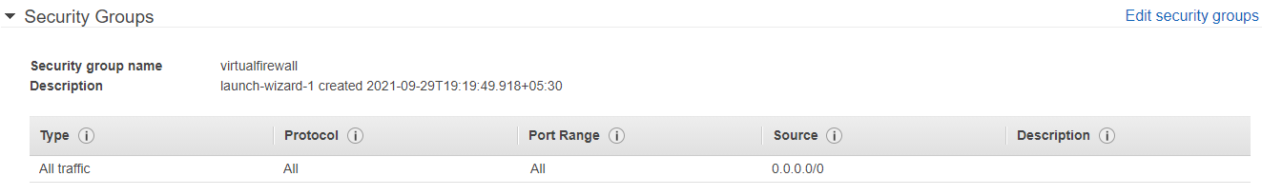

1. Instance Details.

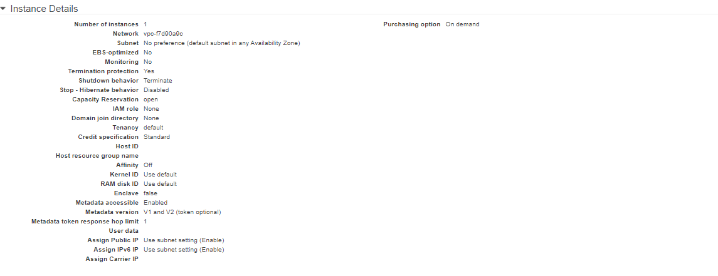

1. Storage Details.

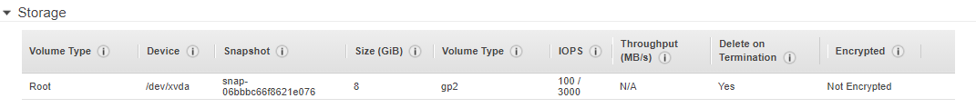

1. Tags Details.

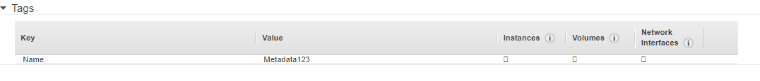

1. Enable termination protection.

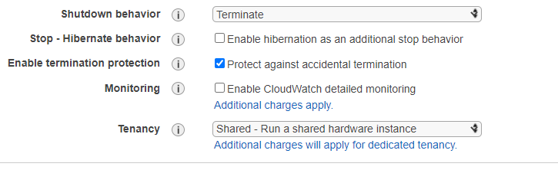

1. Connect to your instance and run a system update.
2. Instance console.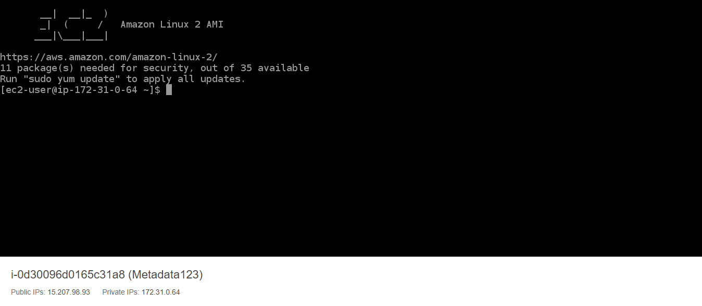
3. Run system update.

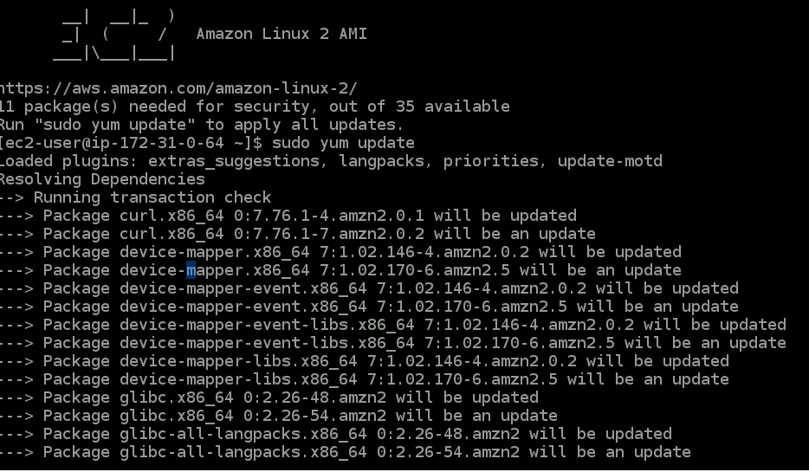

1. Disable termination protection.

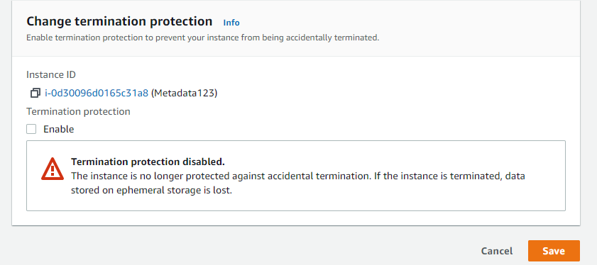

1. Terminate Instance.



Assignment No : 3

Working with volumes

1. Create a Volume.



1. Attach volume to instance.

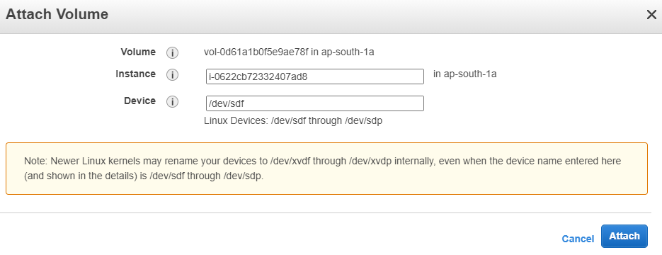

1. Detach Volume.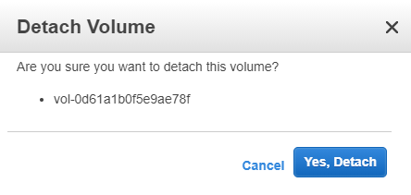
2. Delete Volume.

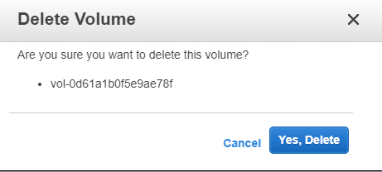

Assignment No: 4

Working with Elastic Beanstalk

1. Deploy sample application on Elastic Beanstalk.

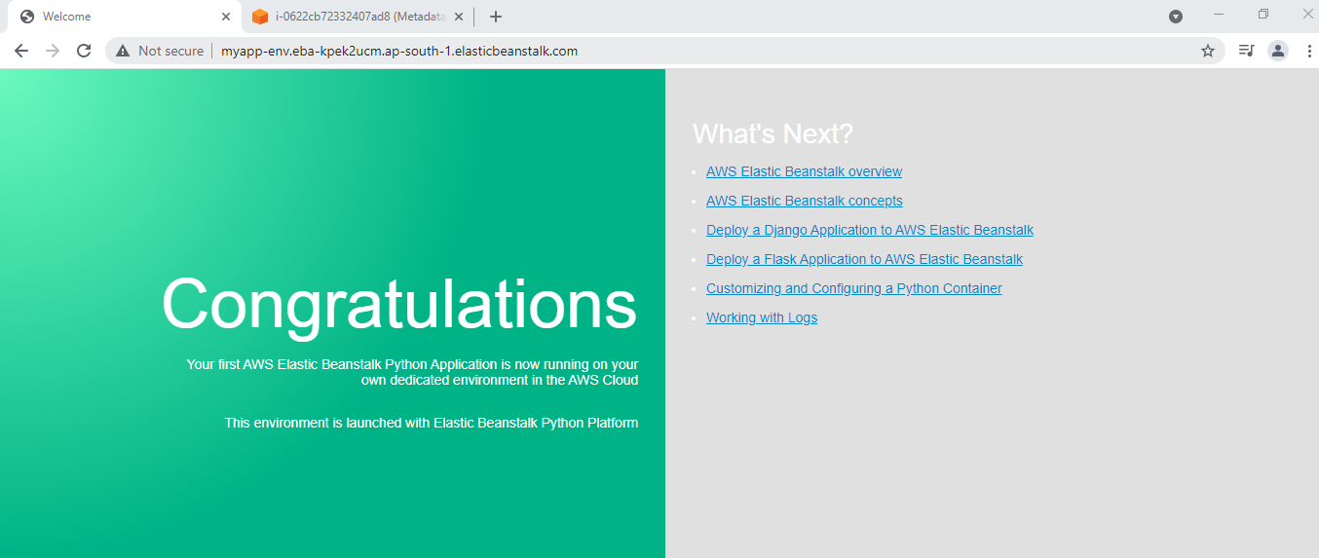

1. Create multiple environments within same applications.

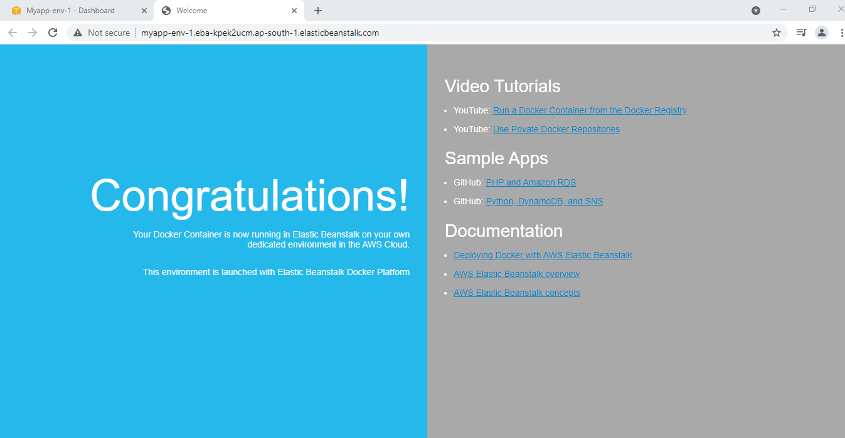

1. Deploy different versions of applications in different environment.

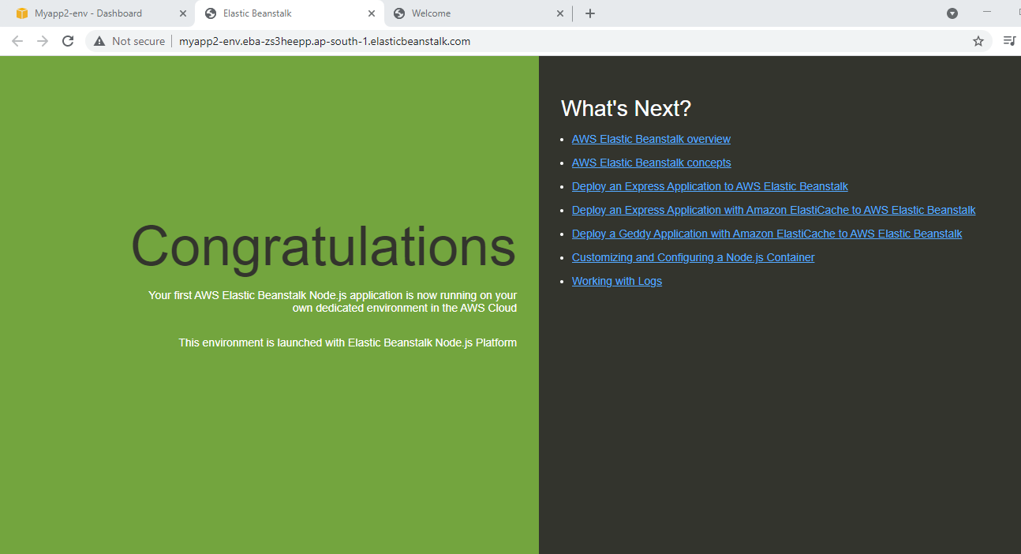

Assignment No : 5

Working with S3.

1. Create an S3 Bucket.

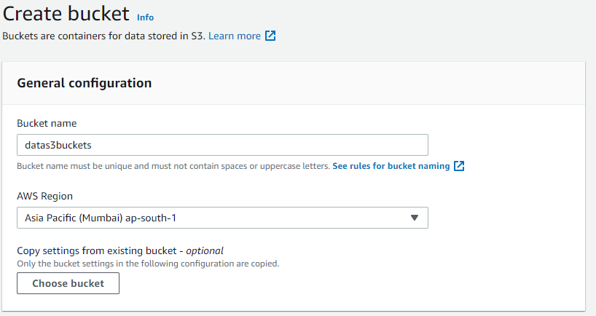

1. Upload object into S3 bucket.

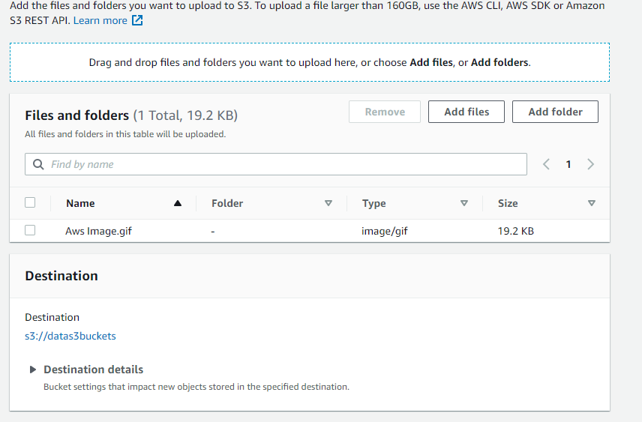

1. Make bucket and object public.

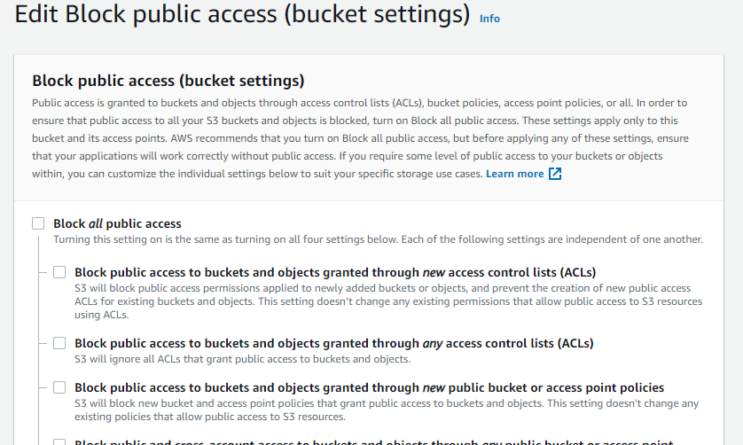

1. Access the object using object url.

